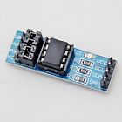

# **AT24C256 Serial EEPROM I2C Interface EEPROM Data Storage Module Arduino PIC**

100% Brand new and high quality

EEPROM stands for electrically erasable programmable read only memory.

It is a secondary storage device that once written (programmed) can hold data even when the power is removed.

If you need more storage for your project, or you want to learn how to use EEPROM, then this module is designed for you.

It supplies an extra 256k byte for your project. You only need simply wire them via I2C.

Size: 3.7x 1.7cm